**Press release** February 2020*Specialist press*

**Thomas Hartkämper is the new CEO of Kautex Maschinenbau – Dr. Olaf Weiland joins the advisory board**

**Starting February 1, 2020, Thomas Hartkämper is the new CEO of Kautex Maschinenbau. He is taking over from Dr. Olaf Weiland, who has had significant influence on the development of the Bonn-based company since 2005. Going forward, Hartkämper is responsible for the areas of operations, research & development, and digitalization. Weiland, who is also a shareholder in Kautex Maschinenbau, is joining the advisory board, which is the controlling body of the company.**

Weiland brought Thomas Hartkämper into the company in October 2019 as the preferred candidate to be his successor, and initially entrusted him with responsibility for operations. The former CEO had put a succession plan into place four years ago, working in consultation with all members of management. His 50-year-old successor is an expert in change management and organizational development. Hartkämper champions a forward-looking approach to business operations, to ensure they are consistently aligned with customer requirements. Prior to joining Kautex, he had an active role for many years in managing various companies that operate internationally in mechanical engineering and plant engineering. He also has extensive experience in the plastics industry.

Weiland himself is retiring from day-to-day operational business, for reasons of age. As a member of the advisory board, he will continue supporting the development of the company that he has guided for more than 15 years. Kautex Maschinenbau has seen massive sales growth under his leadership. With his keen sense of future market developments and his strategic skill, Weiland was able to drive forward the internationalization of the company and its transition from an automotive to a packaging-focused company at an early stage. Managing Partner Andreas Lichtenauer certainly sees Weiland in these terms and highlights “mutual trust in 15 years of cooperation, above all” as well as “continuity and fairness towards customers, employees, and partners” as the key to his success. “Weiland has not only enabled dramatic growth for many years. The fact that we ended the private equity phase two years ago and now belong to a majority shareholder, who invests in Kautex as a family business in the long term, is largely thanks to Olaf Weiland. He also took an active part in arranging his own successor for Kautex with the company’s best interests at heart”, continued Lichtenauer.  
  
Today, Kautex is one of the world’s leading manufacturers of extrusion blow molding machines, with production sites in Germany and China as well as many international branches.

Weiland has this to say of his successor: “I’m glad that Thomas Hartkämper has accepted this challenge. Over the past few months, we have worked closely together to prepare for this succession. Above all, he stands for customer focus and strong team performance. I’m sure that we’ve made the right decision in choosing him to steer Kautex safely, and with the necessary foresight, through the processes of change that are affecting our entire industry.”

Hartkämper himself can already see a positive development: “With the motto ‘BE ONE together with customers and partners to create leading change and added value,’ Kautex has set out to make its organization fit for the future through excellence in processes and leadership. I’m looking forward to the opportunity to play a crucial role, as CEO, in shaping this process in the future.”

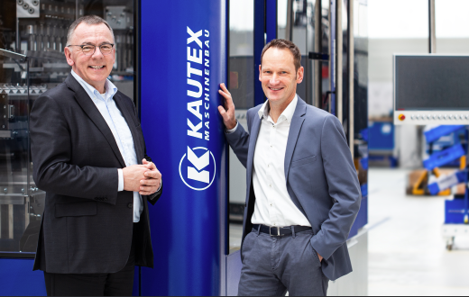

**Caption:**  
Change at the top for Kautex Maschinenbau. Thomas Hartkämper (right in picture) takes over as CEO from Dr. Olaf Weiland (left).

**About Kautex Maschinenbau**Eight decades of providing its customers with innovative products and services have turnedKautex Maschinenbau into one of the world's leading companies in extrusion blow molding technology. With customers that include major automobile manufacturers and suppliers, as well as companies working in the packaging industry. All of them have come to rely on the knowledge and experience of a brand that stands for both quality and reliability. In addition to its HQ in Bonn, a Customer Service Center in Berlin and regional offices in the USA, Russia, China, Italy, India, Mexico and Malaysia, Kautex Maschinenbau operates an extensive global network of service and distribution offices. **Contact details**

**Christian Kirchbaumer**  
Head of Marketing Communications

**Kautex Maschinenbau GmbH**  
Kautexstr. 54  
53229 Bonn  
Germany

T +49 228 489370

christian.kirchbaumer@kautex-group.com